**CREATE A GOOGLE MY BUSINESS PROFILE**

1. **INTRODUCTION** 
   1. **overview**

the project based on Google website creating a advertisement on Google because now a days are very marketing rate high demanding on the supplier and import and export advertisement cost are high also use

**1.2 purpose**

Create a business profile and developed Google business profile on digital marketing on basics knowledge of the Google creating a new business profile list our of the items and products sales Executive customers

1. **PROBLEM DEFINITION AND DESIGN THINKING**

**2.1 Empathy map**

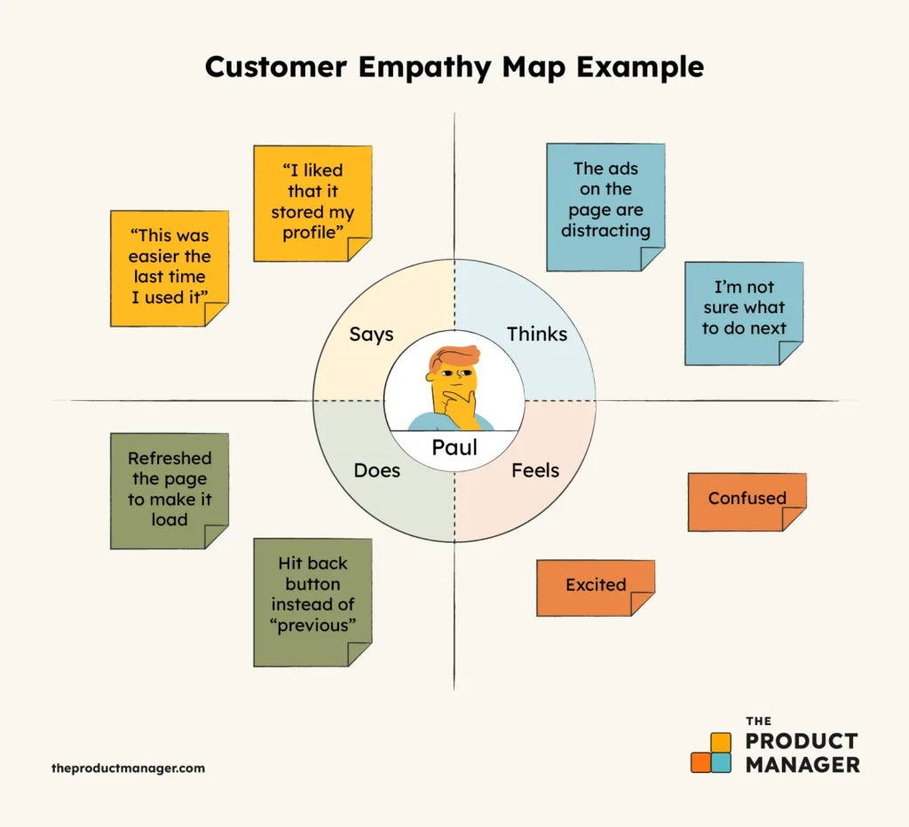

**2.2 Ideation & Brainstorming map**

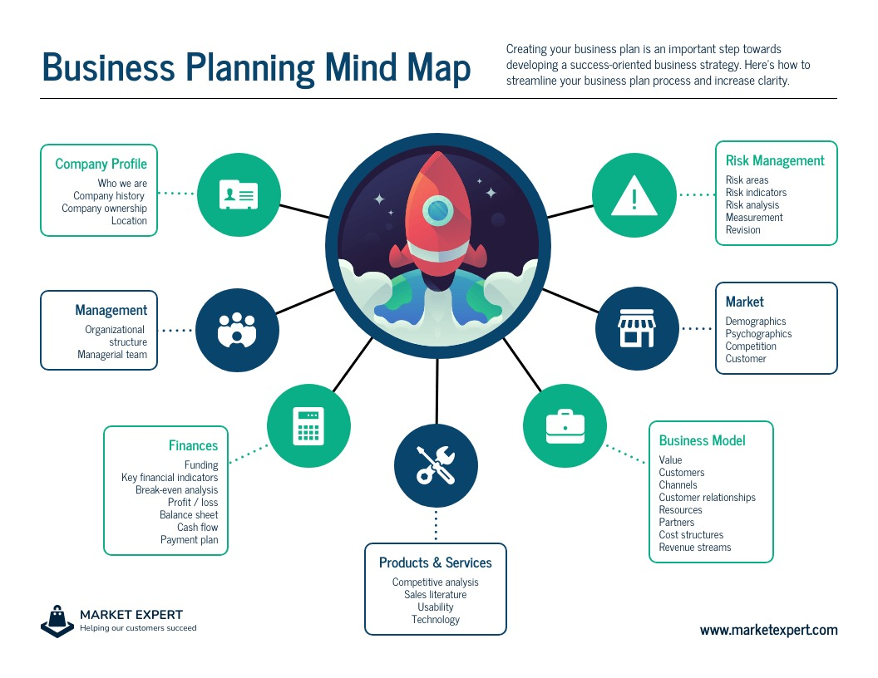

**RESULT :**

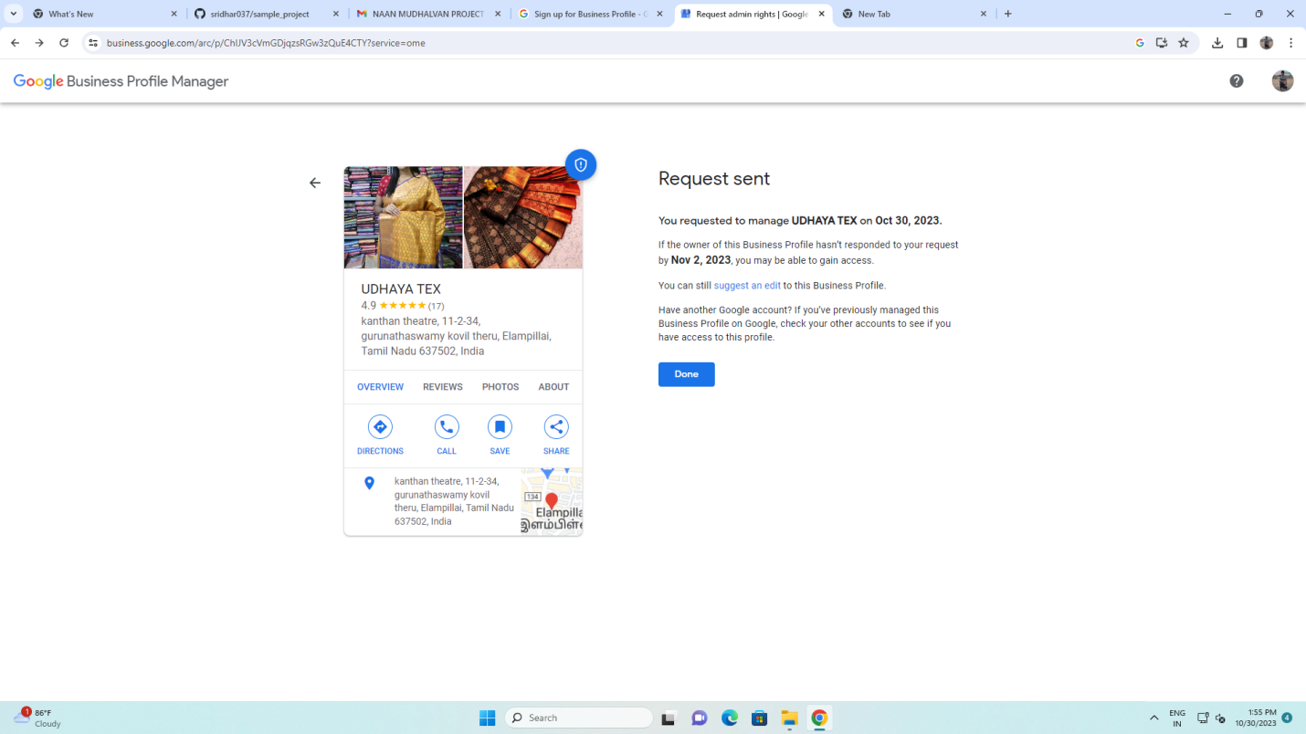

**Website link :**

[**https://sridhargroups037.blogspot.com/2023/10/create-google-profile.html**](https://sridhargroups037.blogspot.com/2023/10/create-google-profile.html)

**Git hub link:**

[**https://github.com/sridhar037/sample_project**](https://github.com/sridhar037/sample_project)

**youtube:**

**https://youtu.be/0727NMlWXz8?si=2DfPpl4Bh9ddghD4**